**PE3 PROJECT**

**190030717**

**M. Kanakavalli**

**Create and Deploy AWS Lambda Using Server less Framework by automating the creation of Lambda Function through Code**

**Procedure:**

Step 1: Install NodeJS on your Local Machine

Step2: Install Serverless in your system using the command **npm install –g serverless**

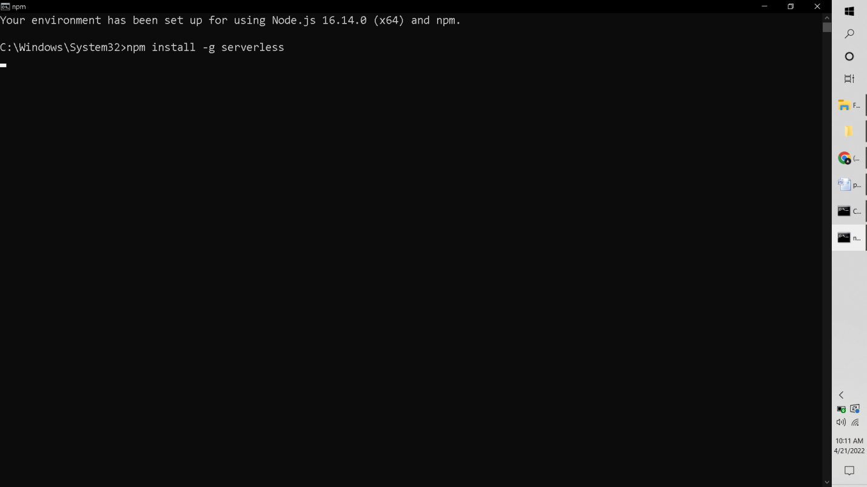

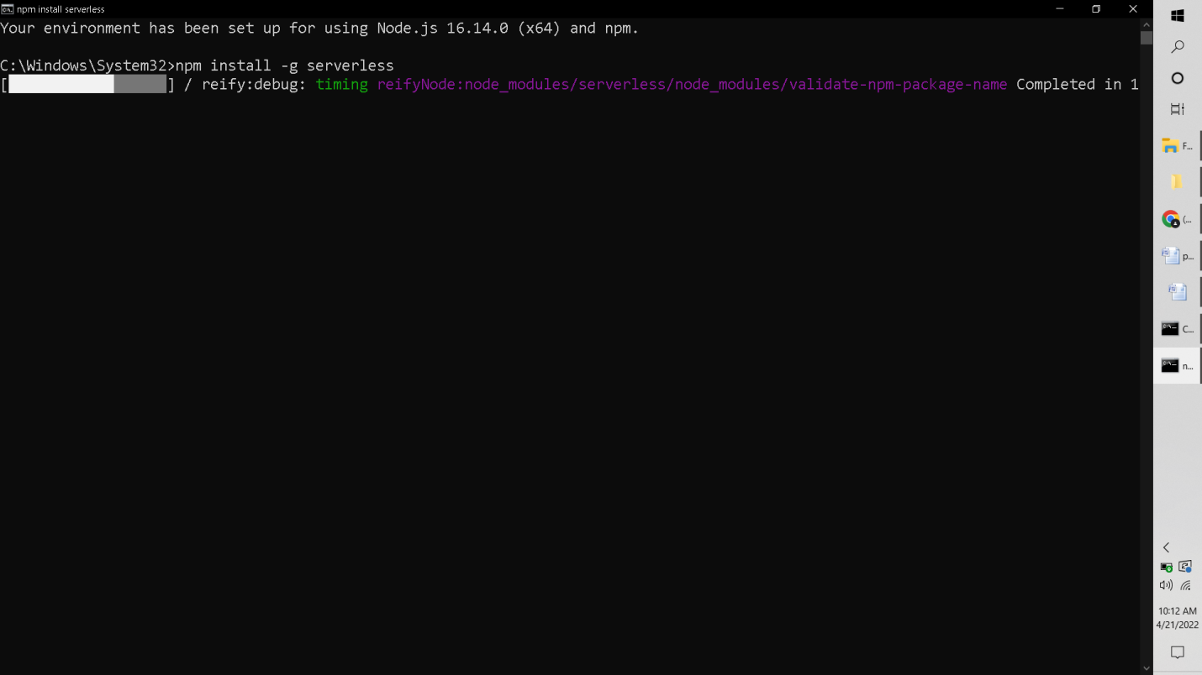

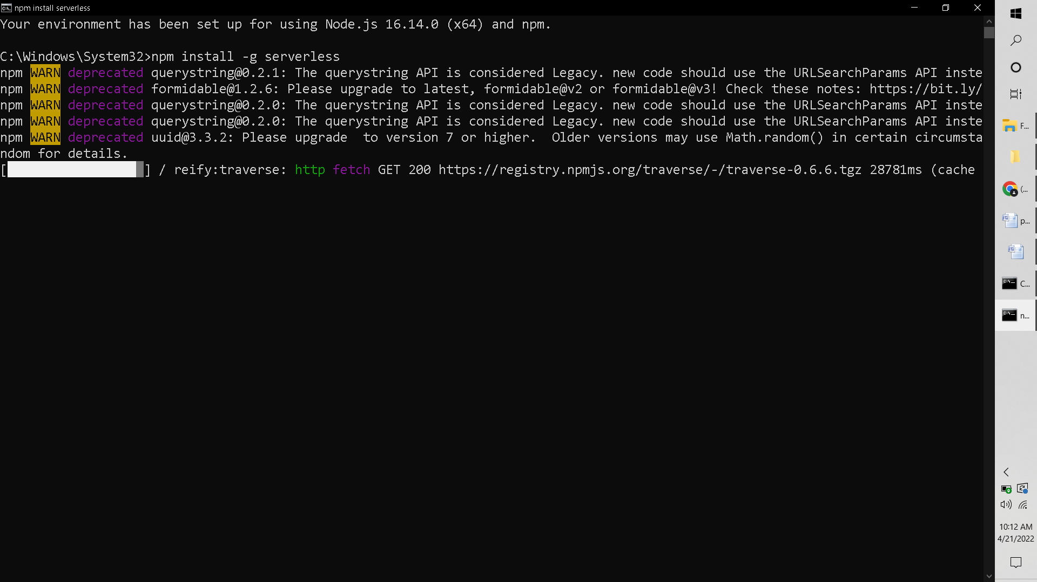

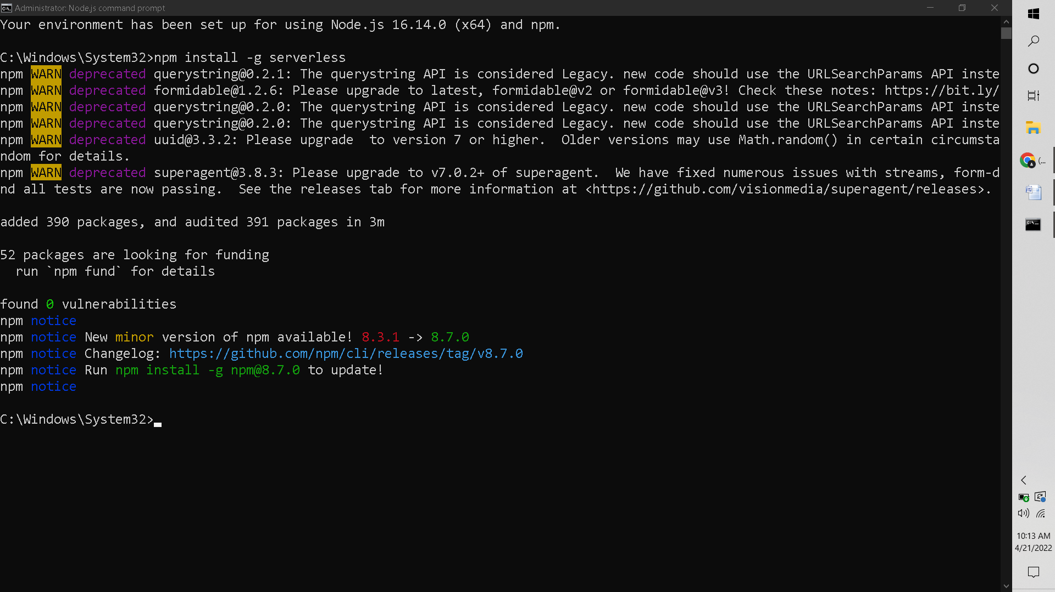

Step3: After installing, Open IAM console and create a IAM USER and IAM Role to integrate with Lambda Function:

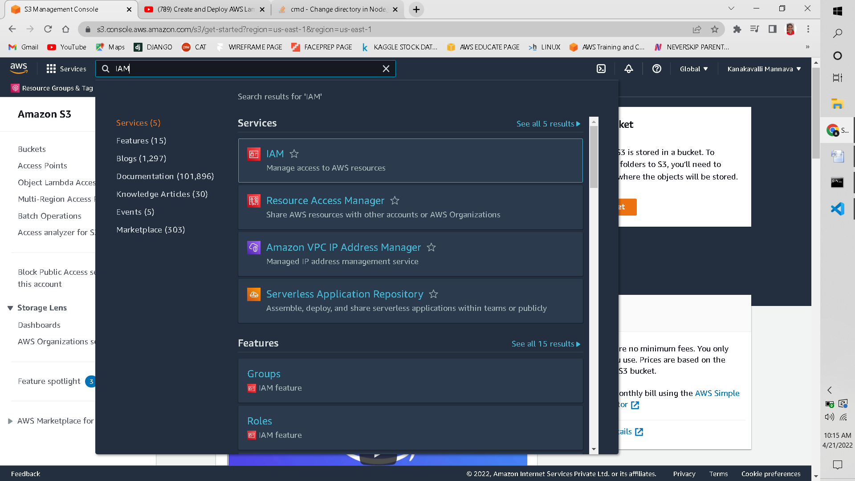

3.1: Click on users and select Add User, give an appropriate user name and tick Access Key- Programmatic Access.

3.2: Now select Attach Exiting Policies Directly and select Administrator Access

3.3 Review your changes

3.4: Create User

3.5: Now make note of the Access Key ID and Secret Access Key.

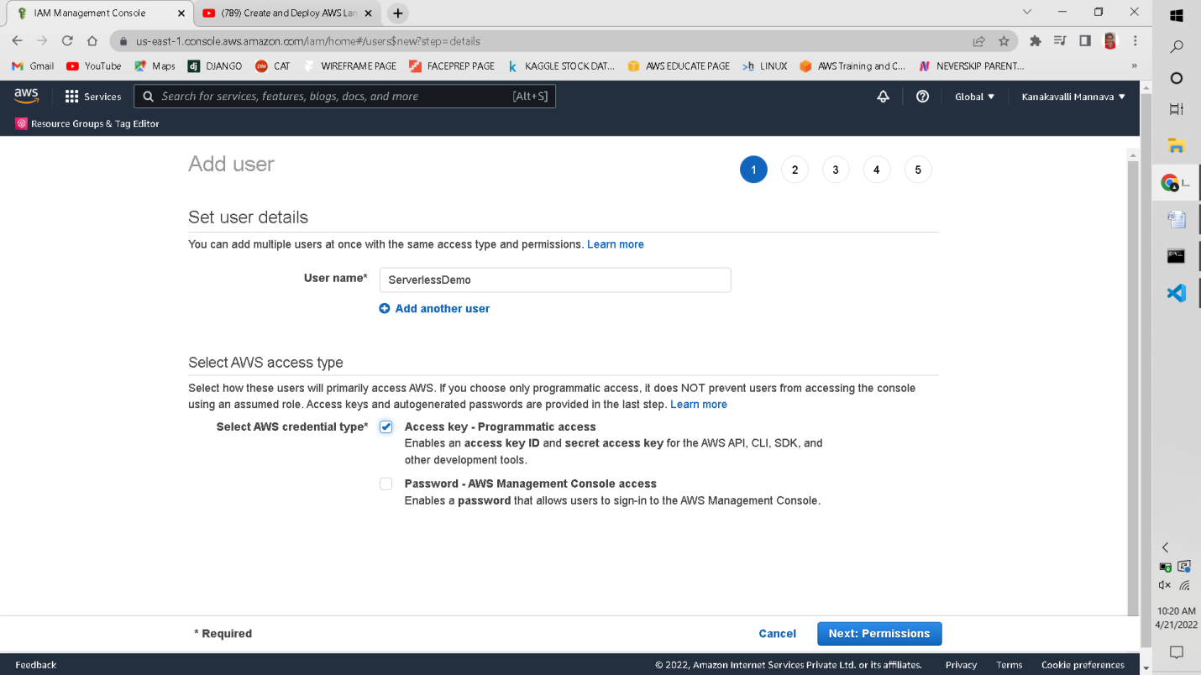

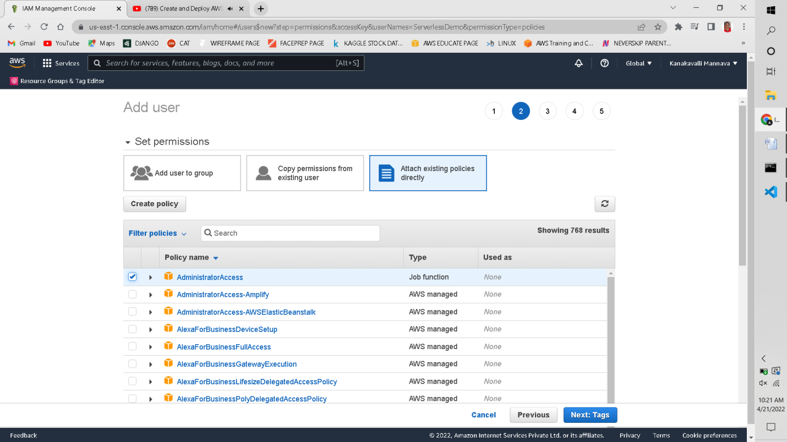

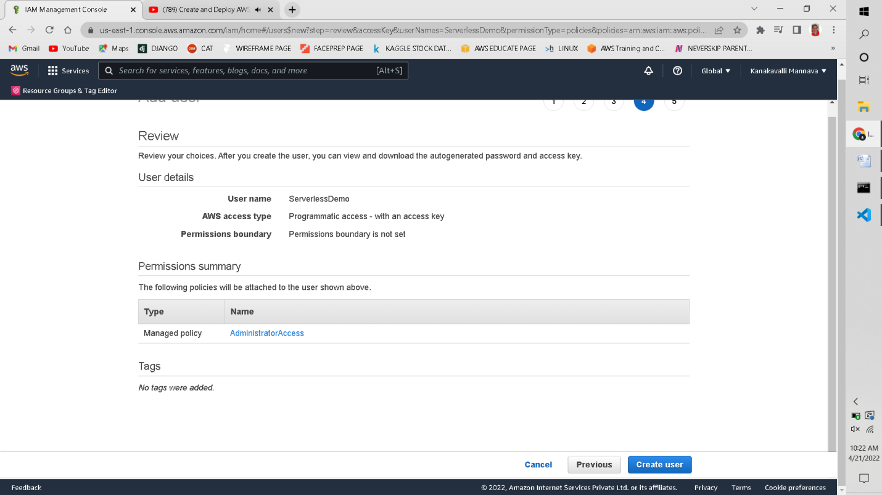

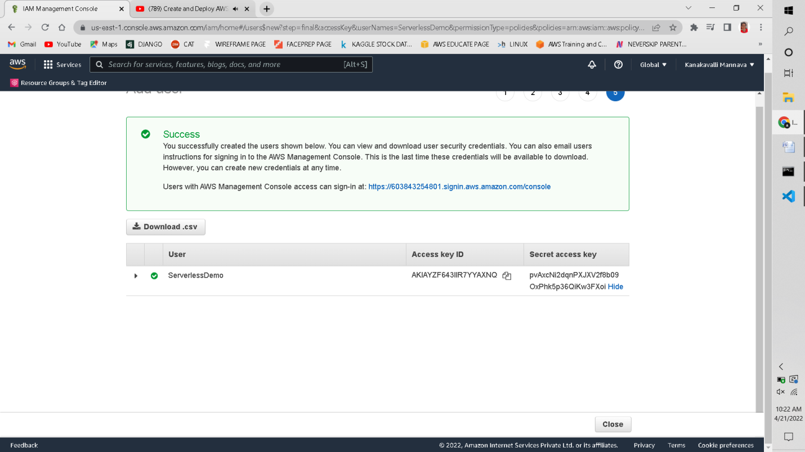

Step4: Now create an IAM Role and select Lambda

4.1: Give AWSLambda_FullAccess permission

4.2:Give Role Name: ServerlessDemo and create the role

4.3: Make note of the IAM Role ARN.

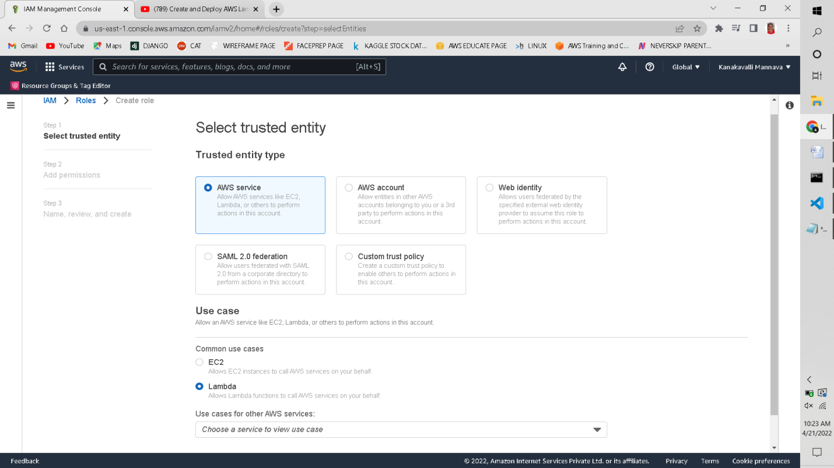

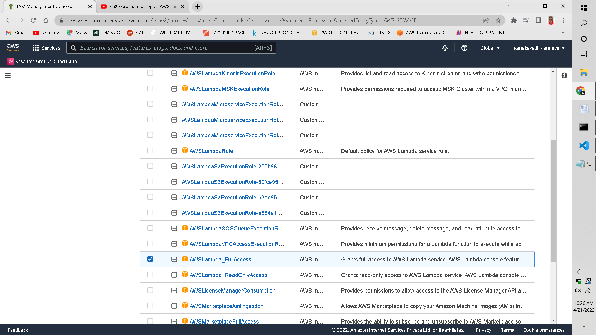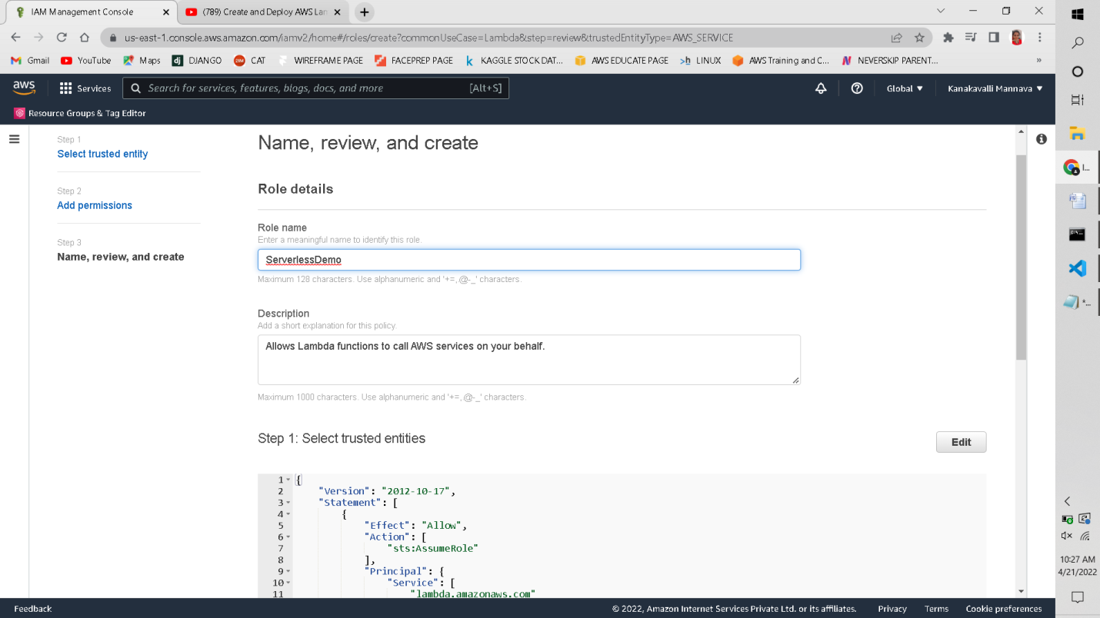

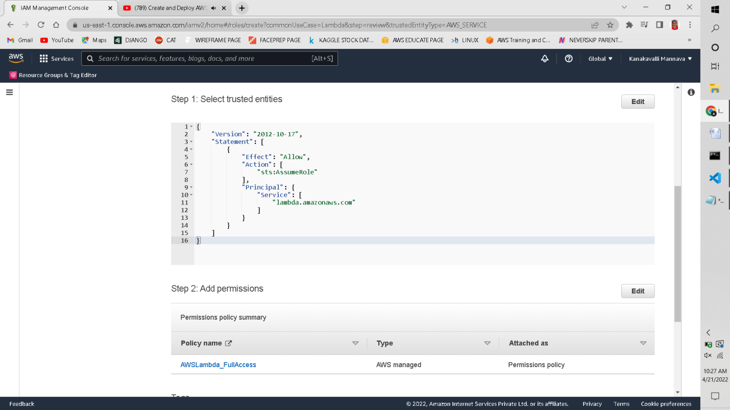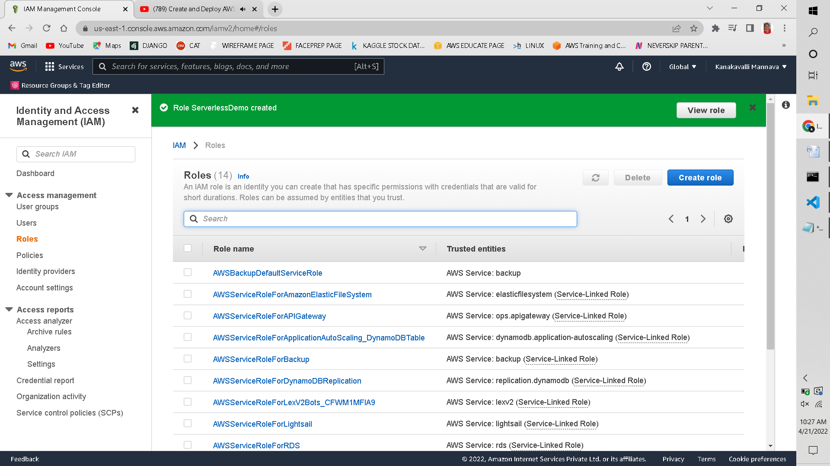

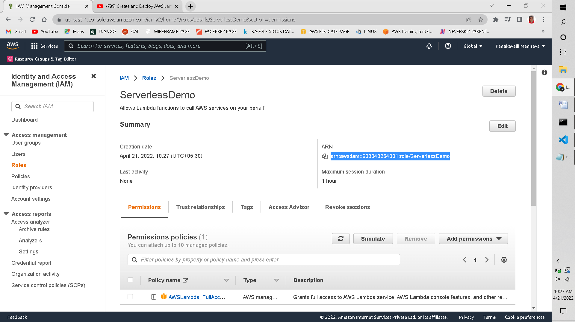

Step5: Now navigate to your Project Folder and Open Visual Studio Code.

Step6: now type the following command: **serverless create –t aws-nodejs**

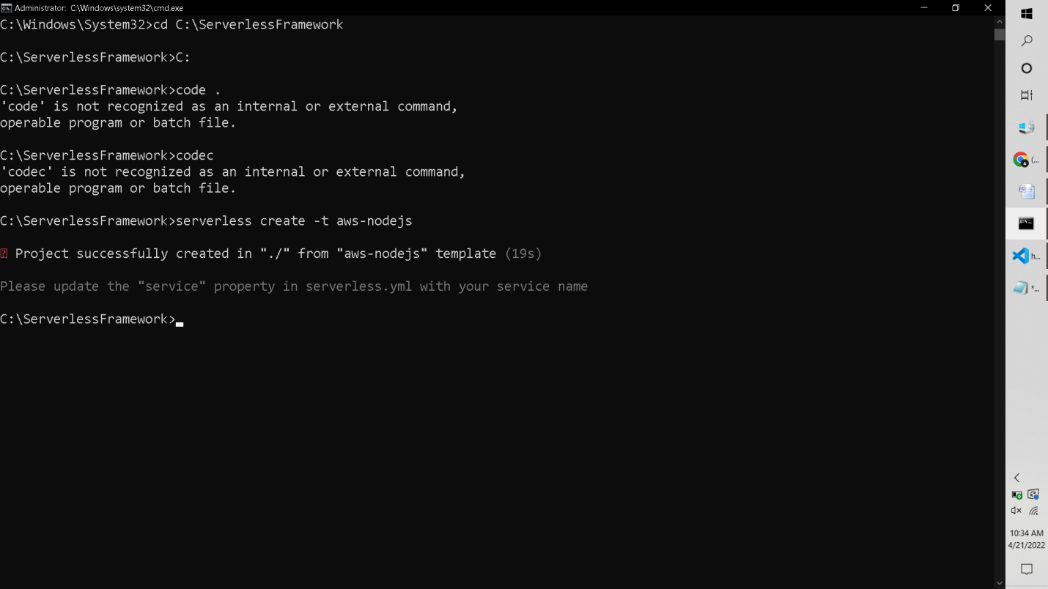

Step7: 3 files will be created as shown in the below picture:

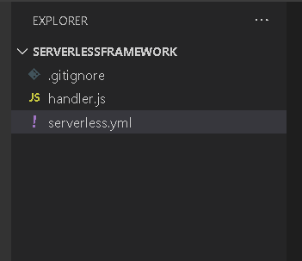

Step8: Modify the code in **handler.js**and **serverless.yml.**

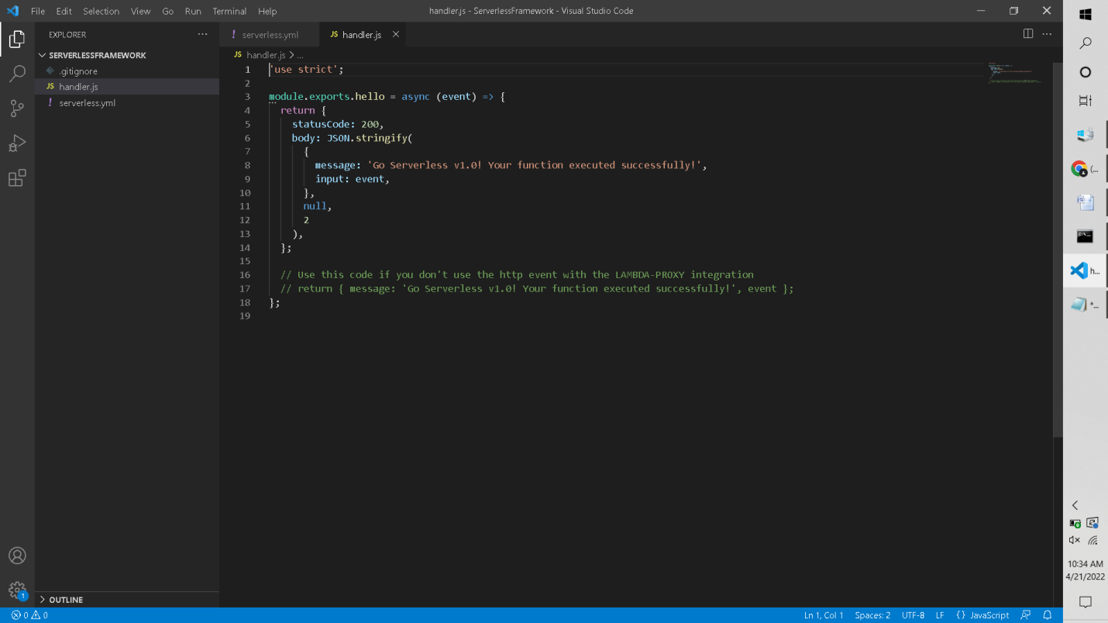

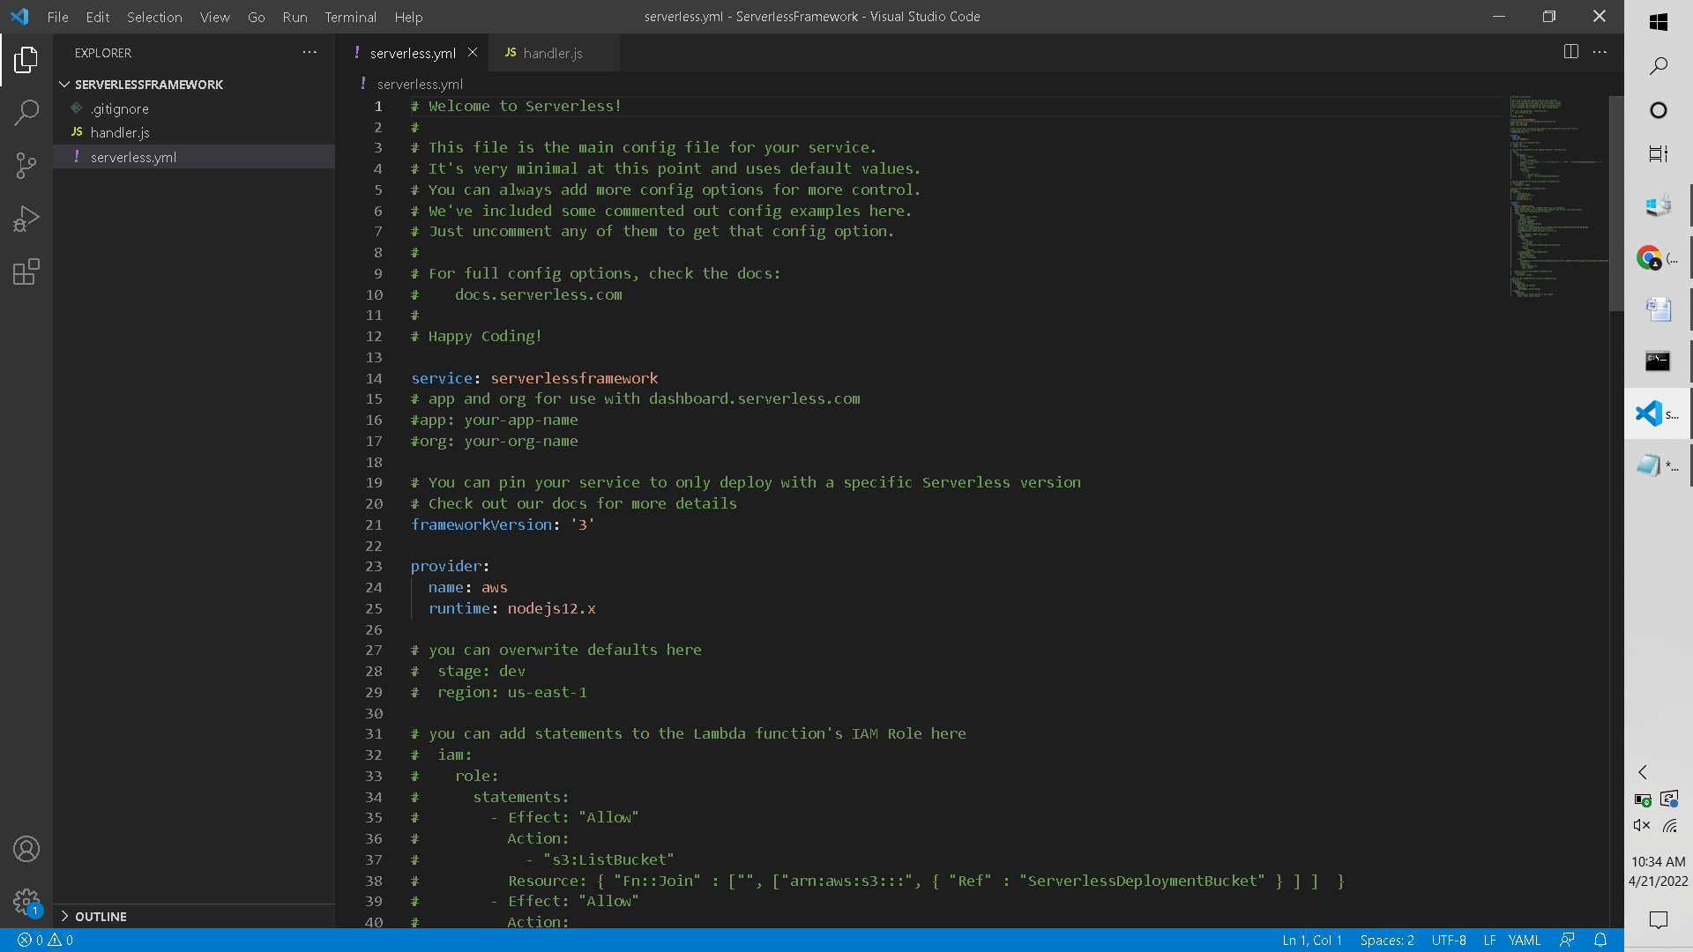

Step9: Make the following Changes to the code and change the function name from “hello” to “ServerlessDemo” :

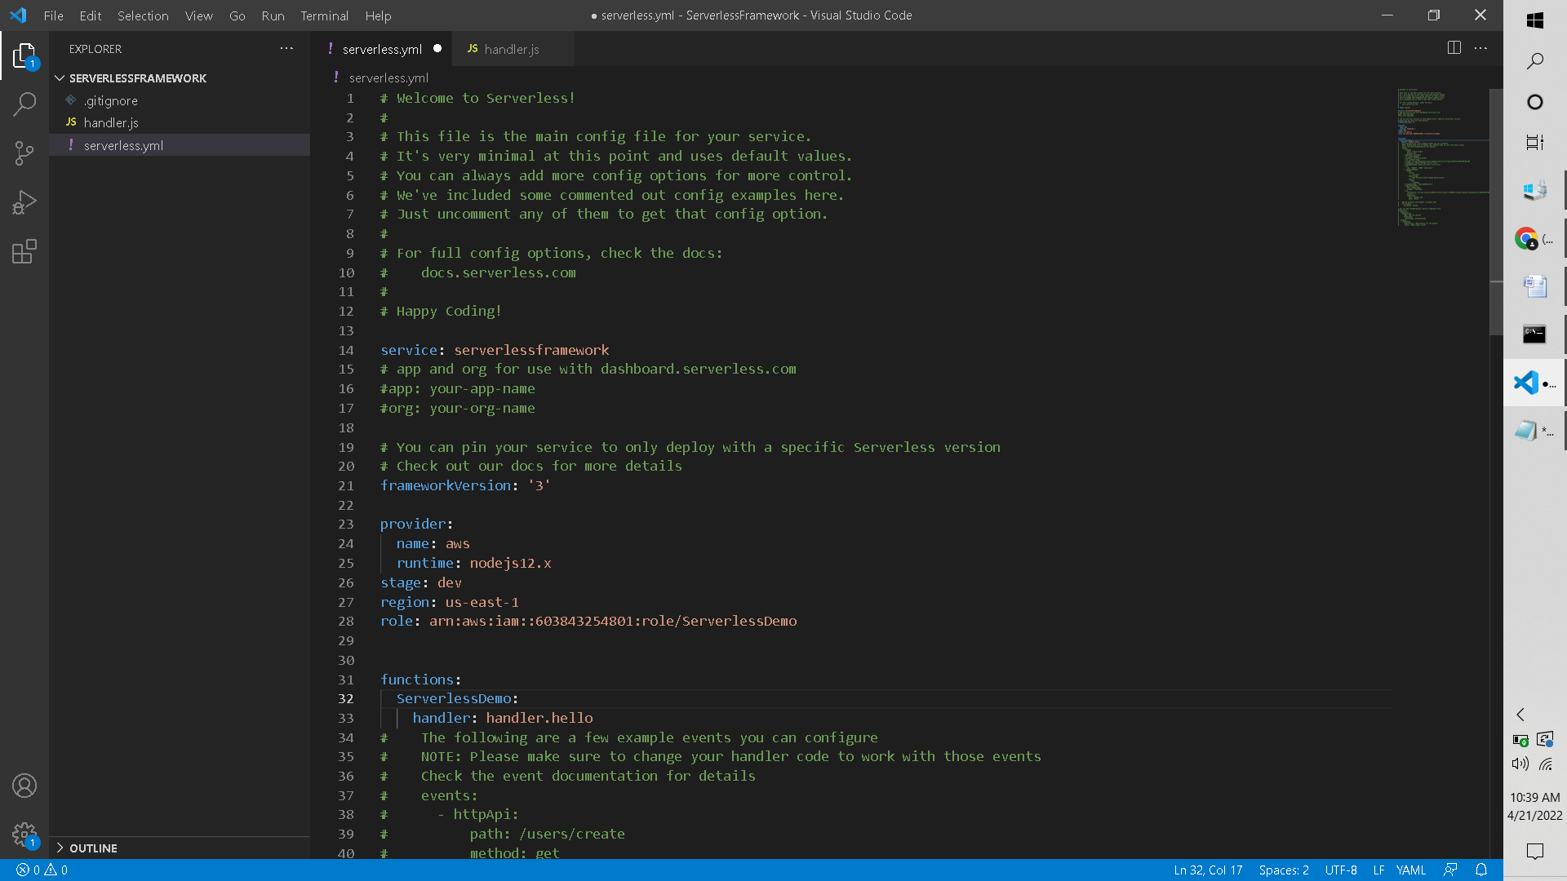

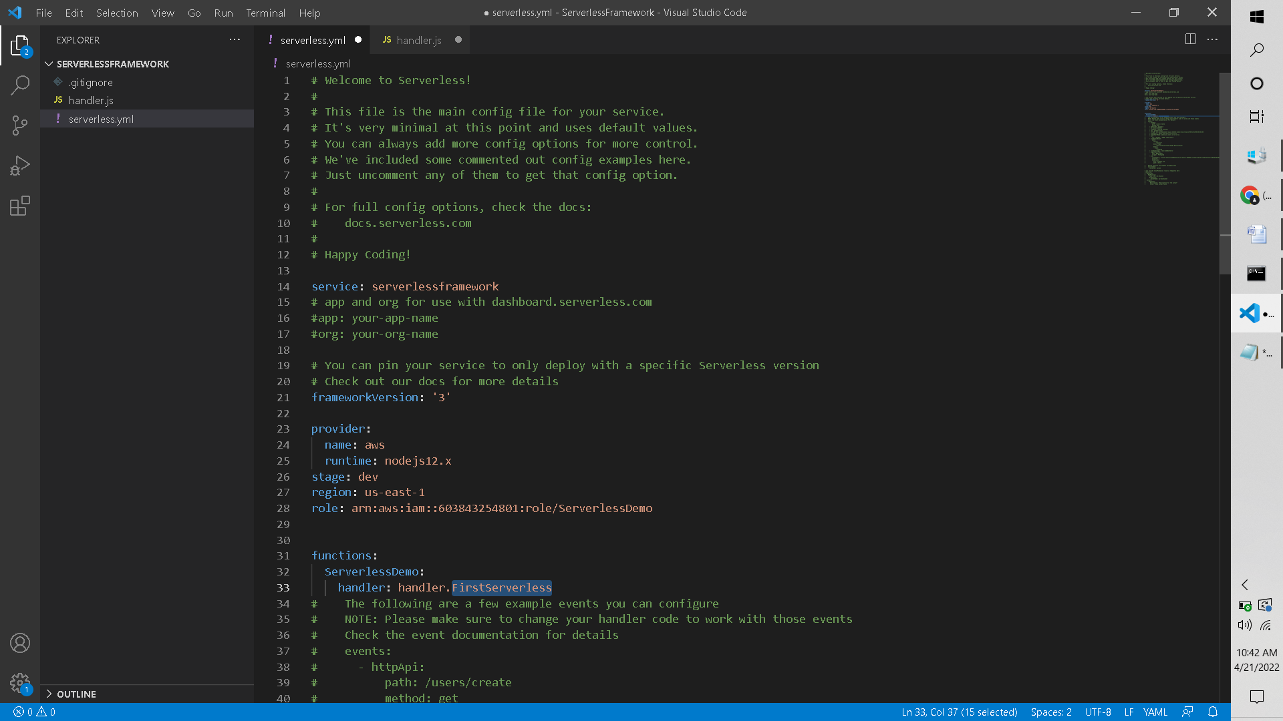

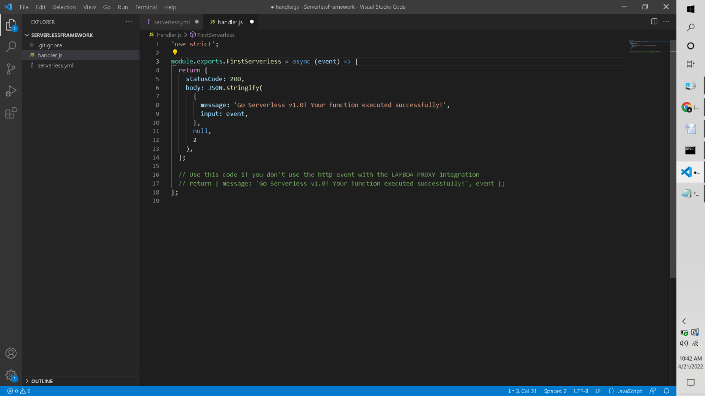

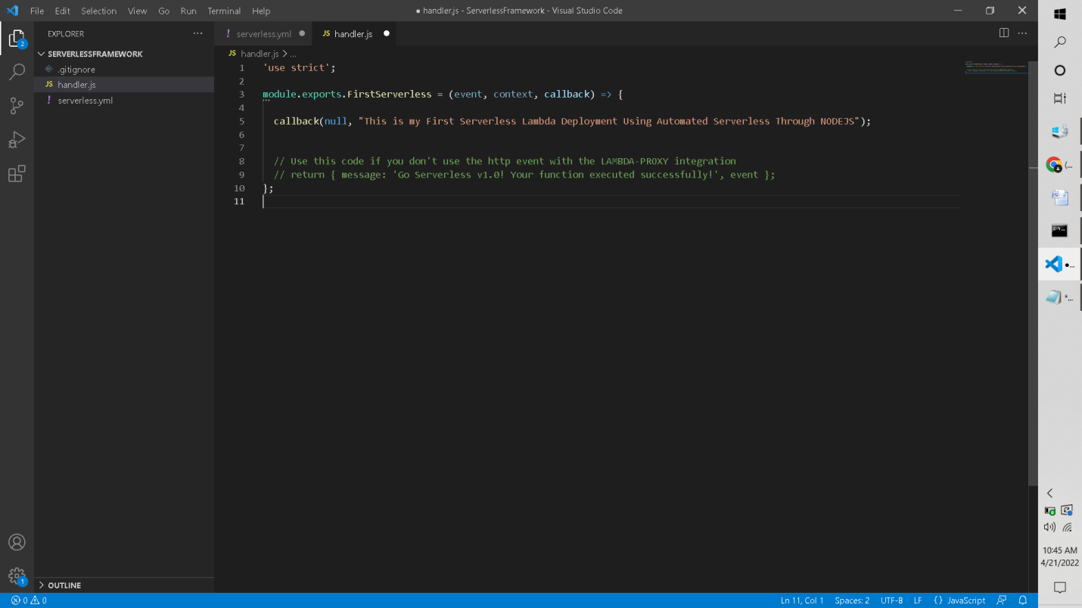

Step10: Now all the code and serverless is ready and we need to deploy the code

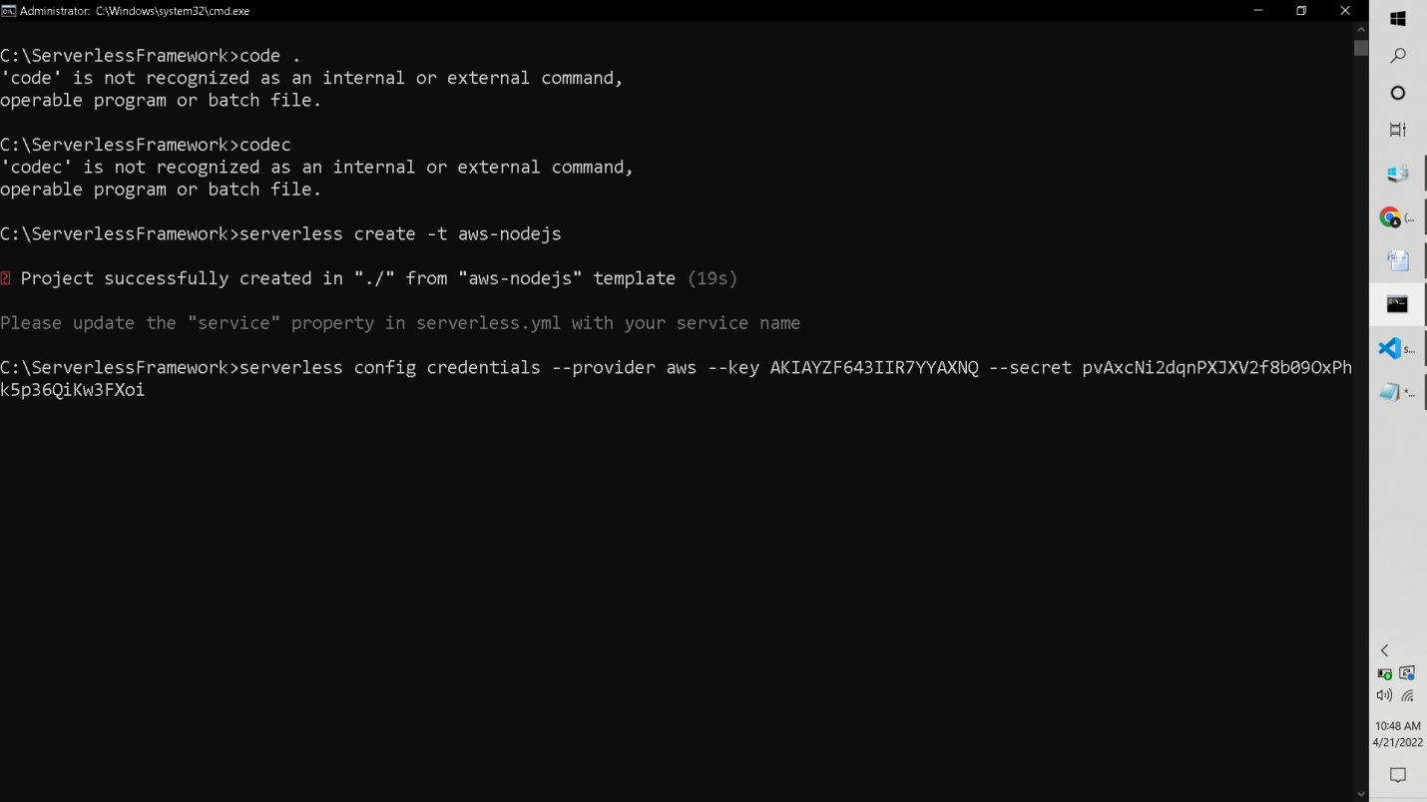

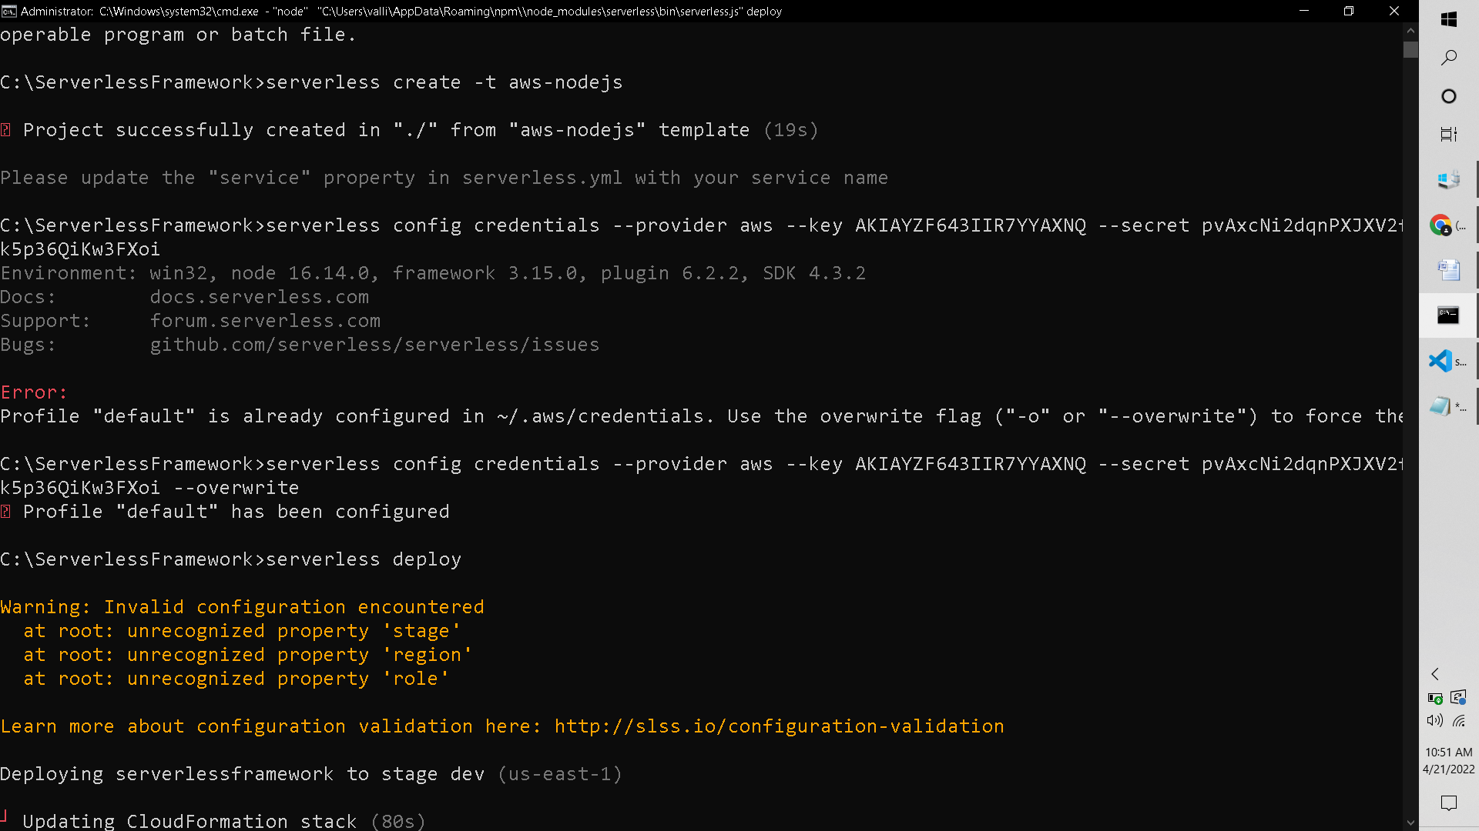



Hurray! The Lambda function is created automatically using the serverless.

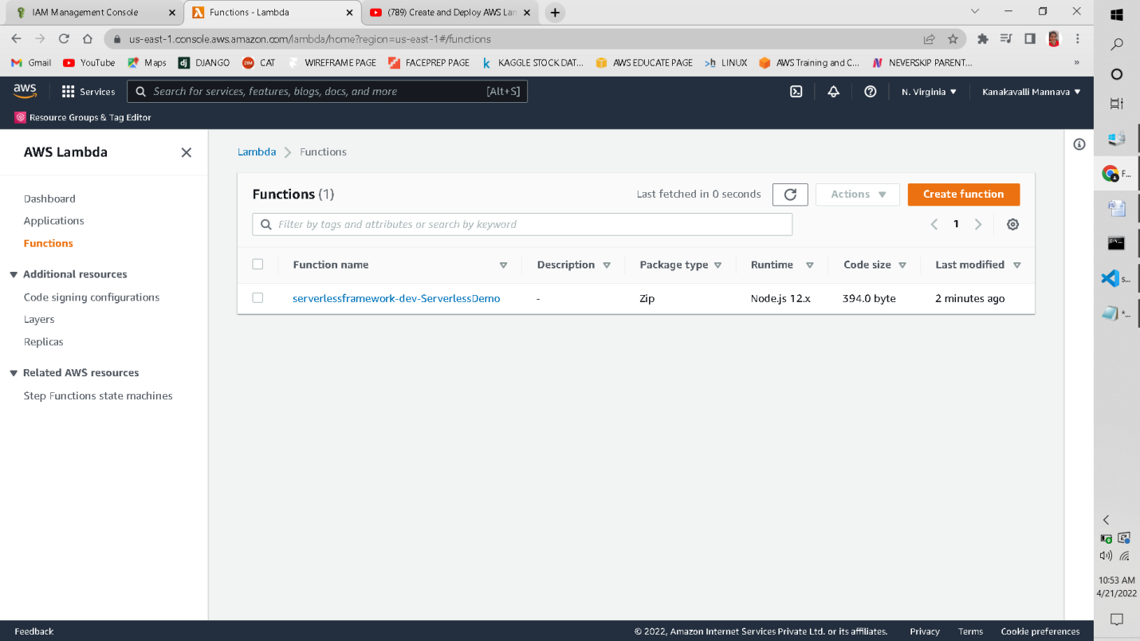

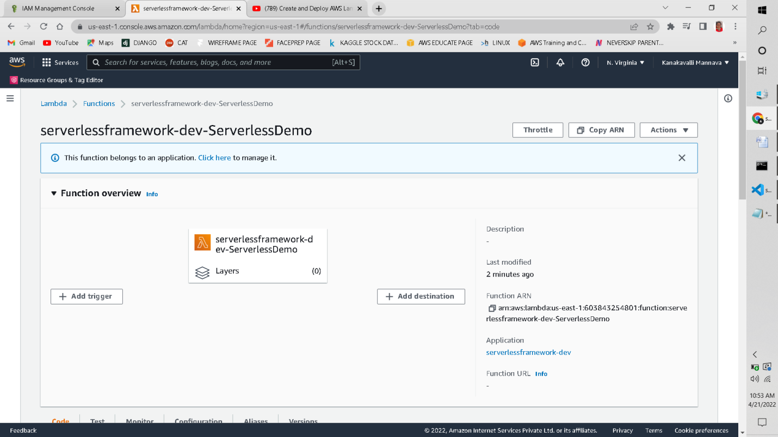

This code is exactly the same code which we provided in the Visual Studio Code

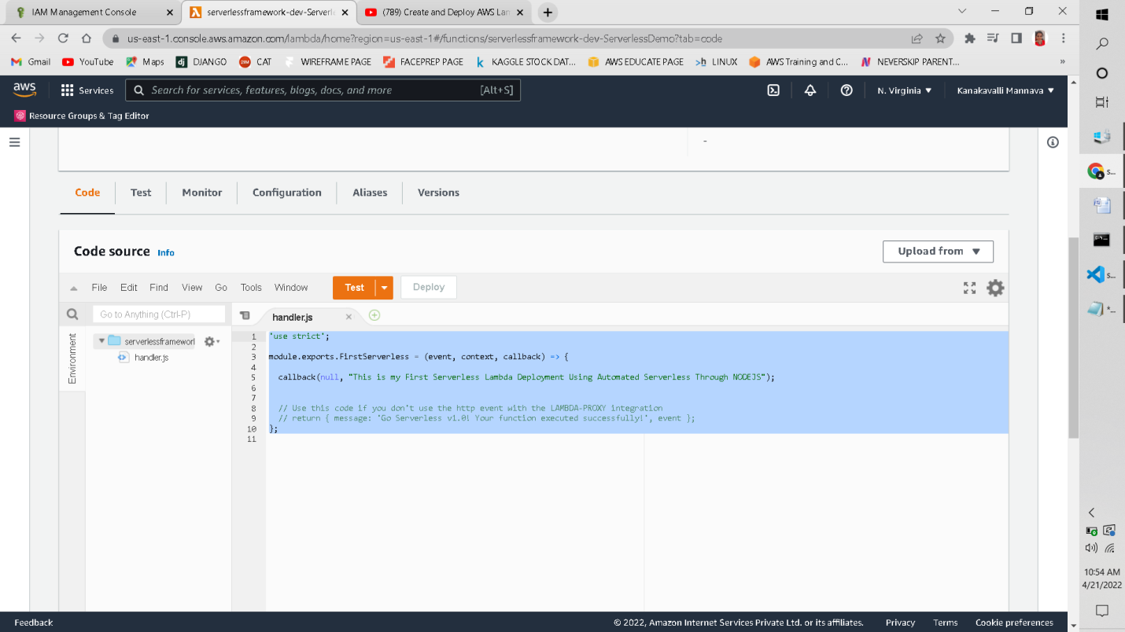

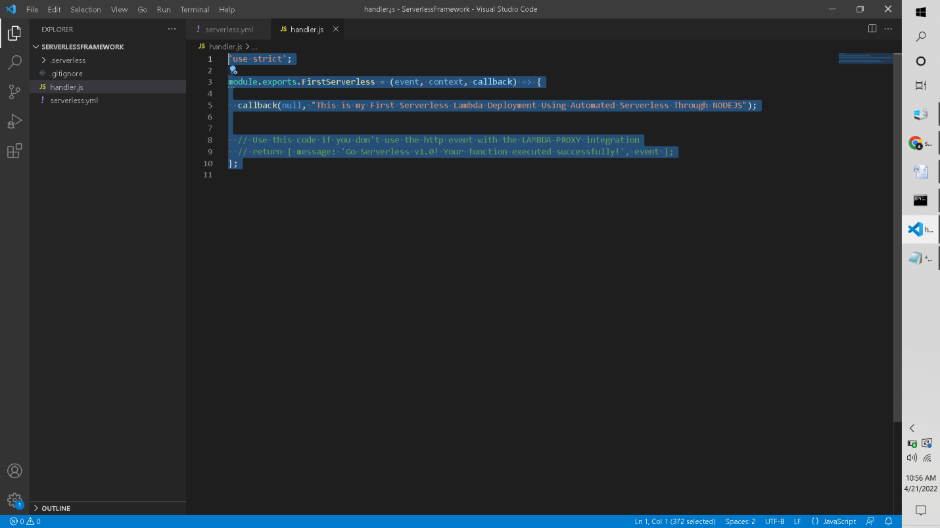

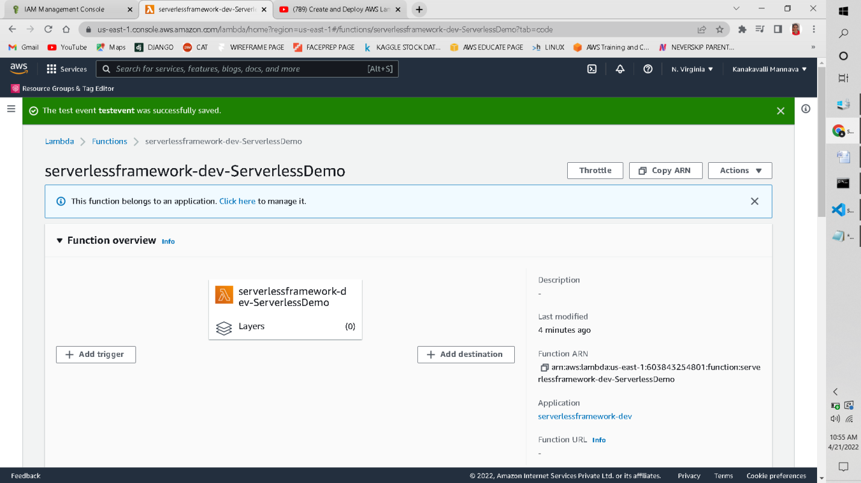

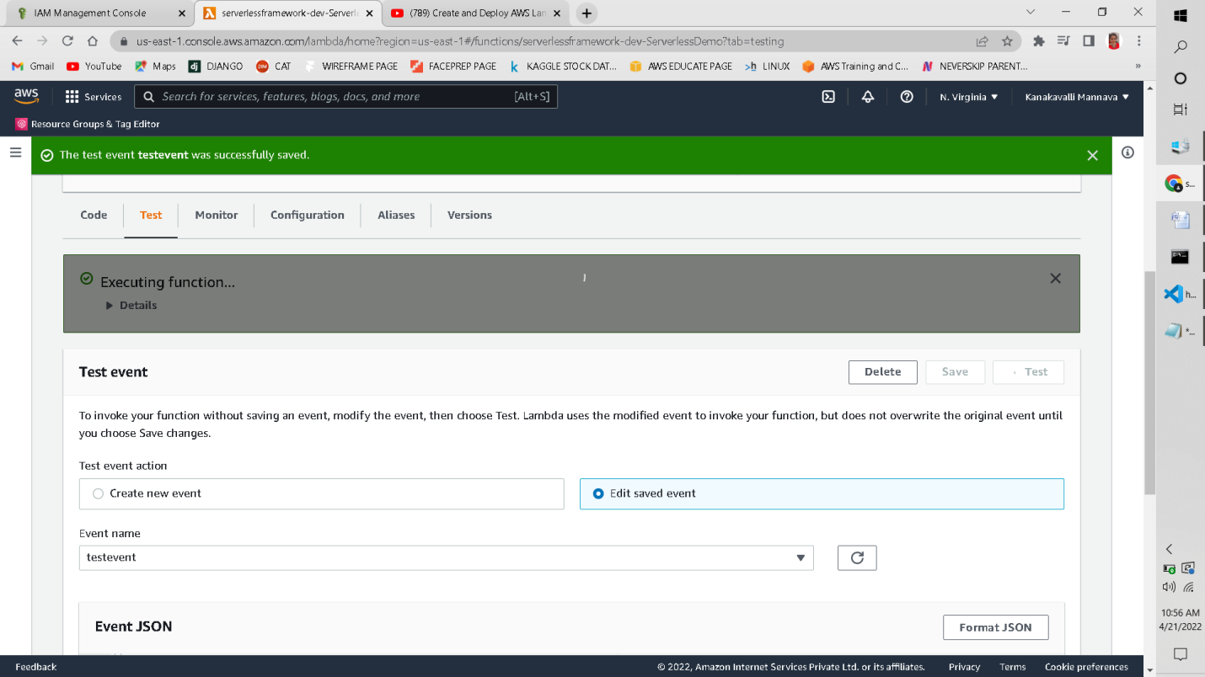

The test results are successful and the lambda function returned the message that we provided

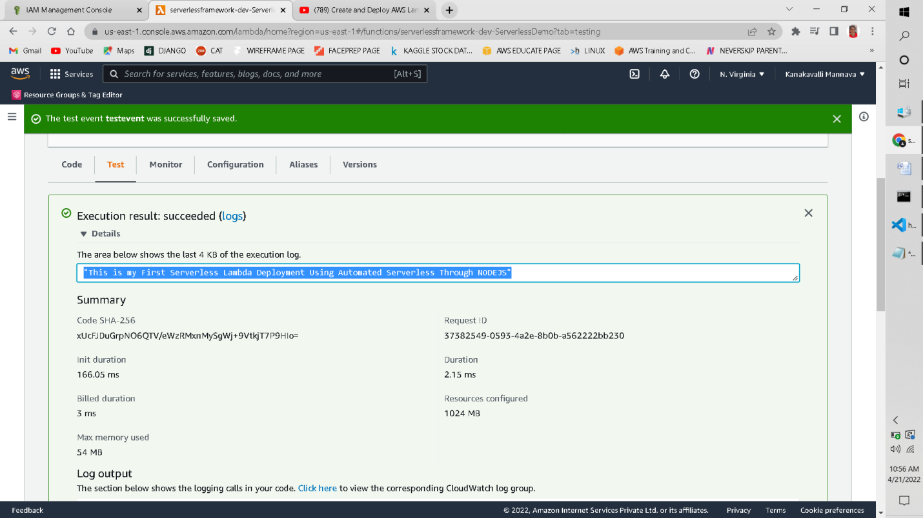

LogOut Output:

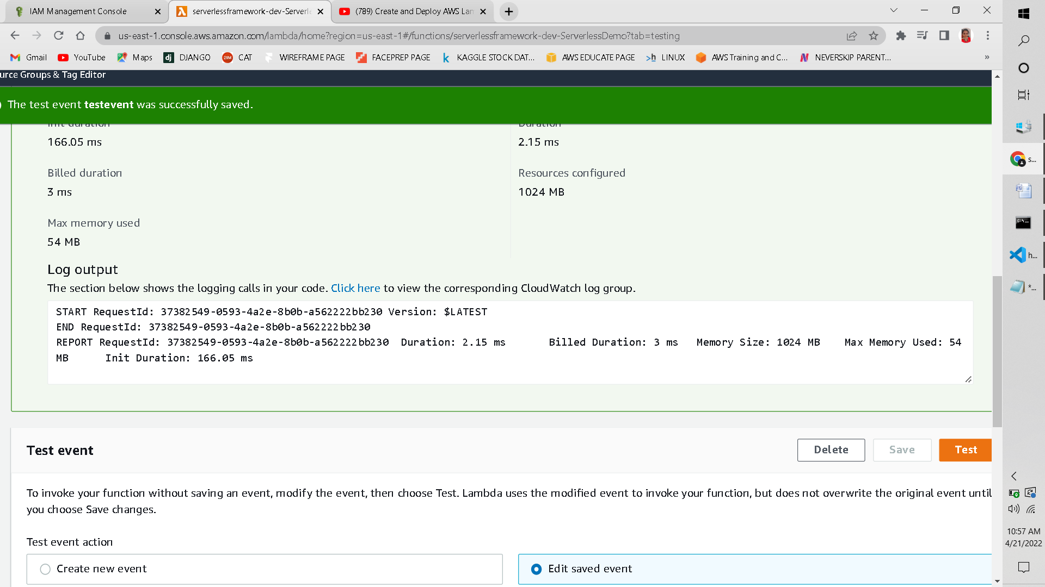

As you can see an S3 Bucket is also automatically created as we invoke lambda function through the code written in Visual Studio Code

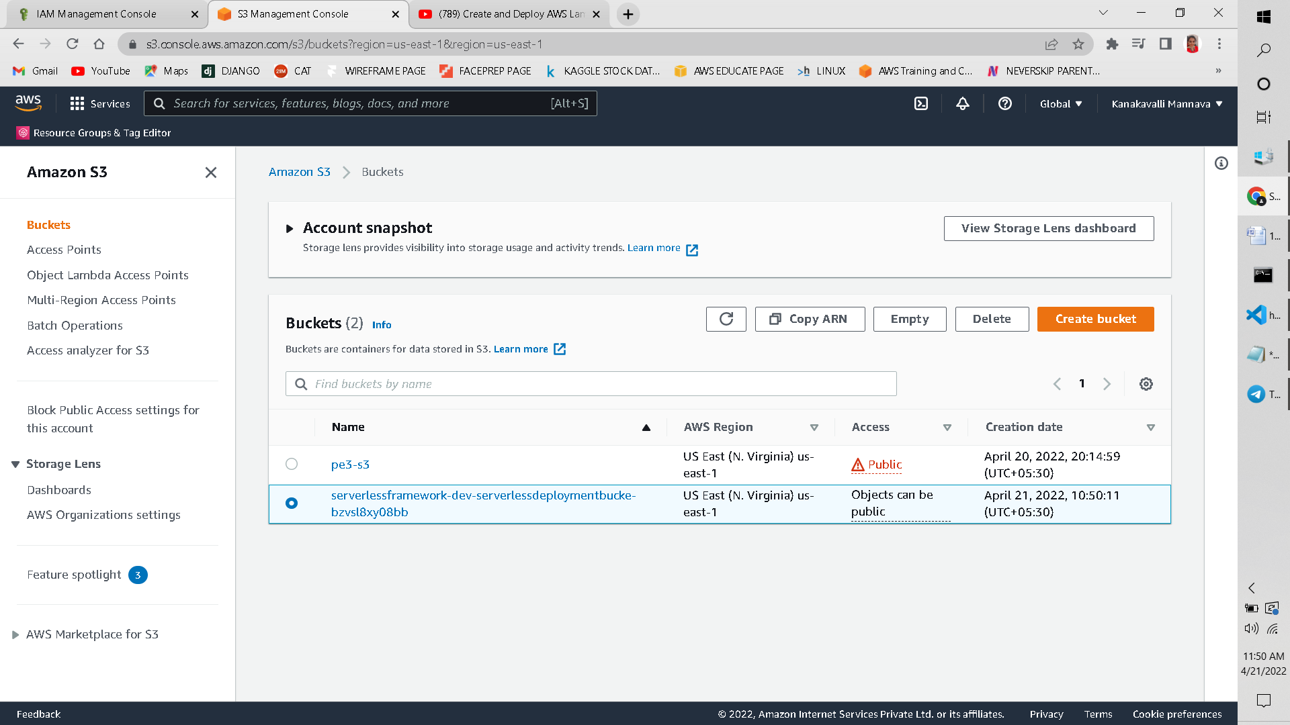

Objects are auto uploaded to the S3 Bucket:

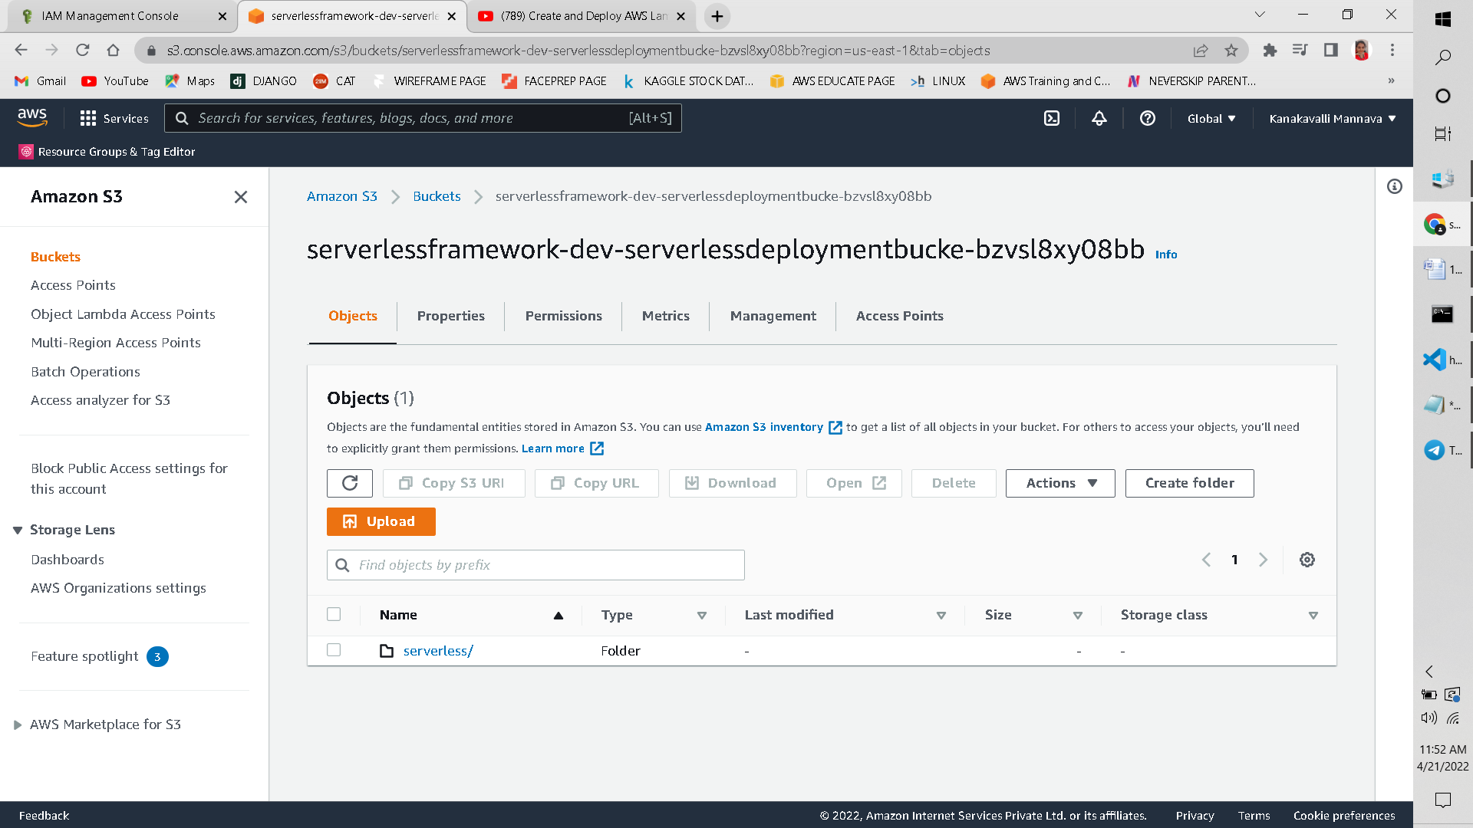

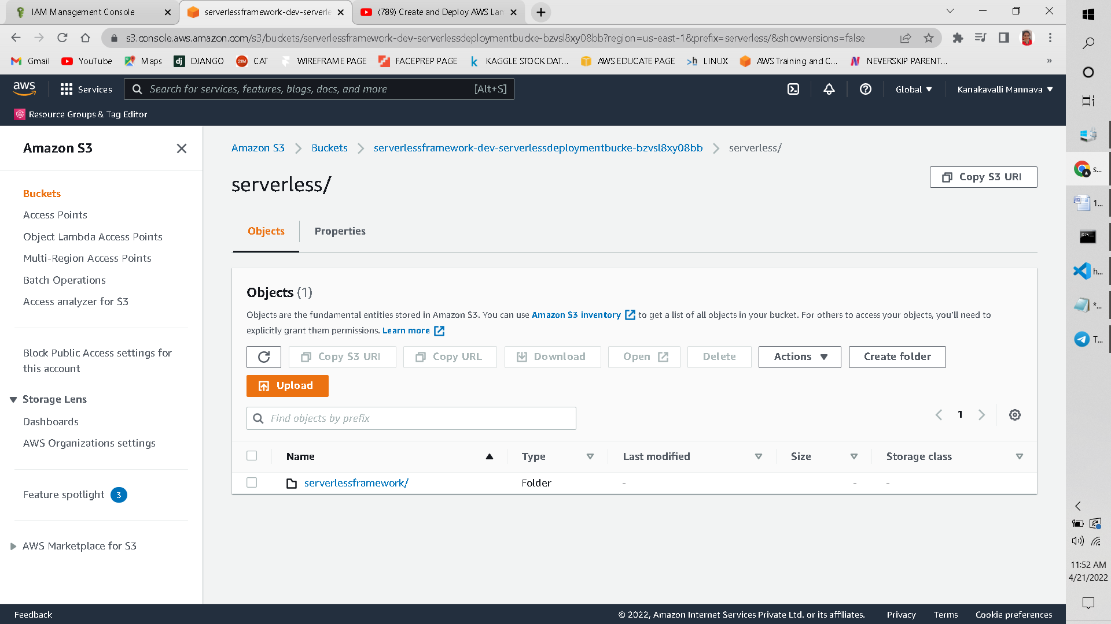

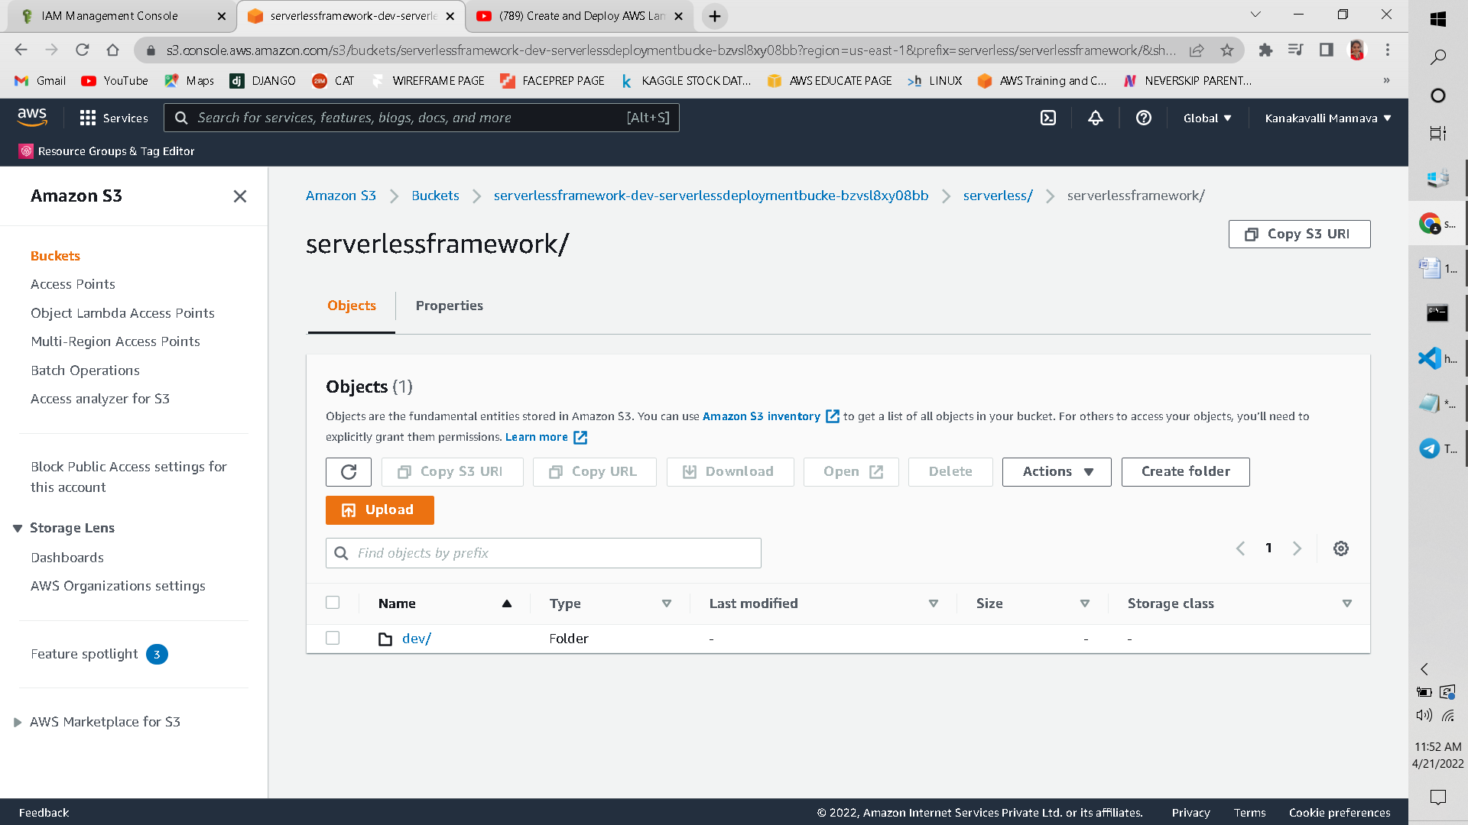

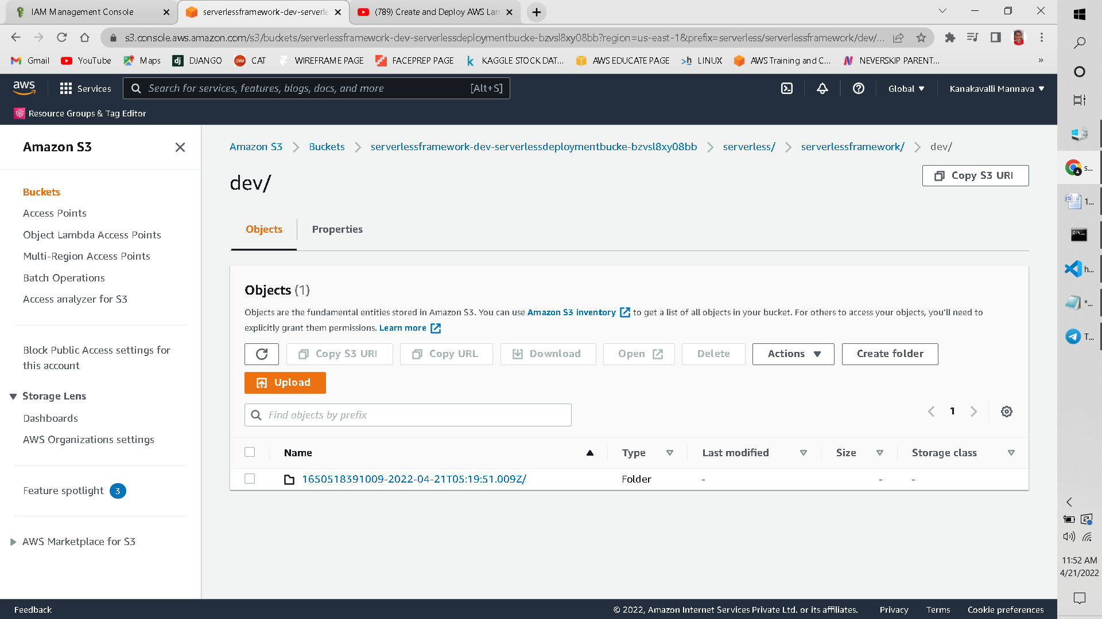

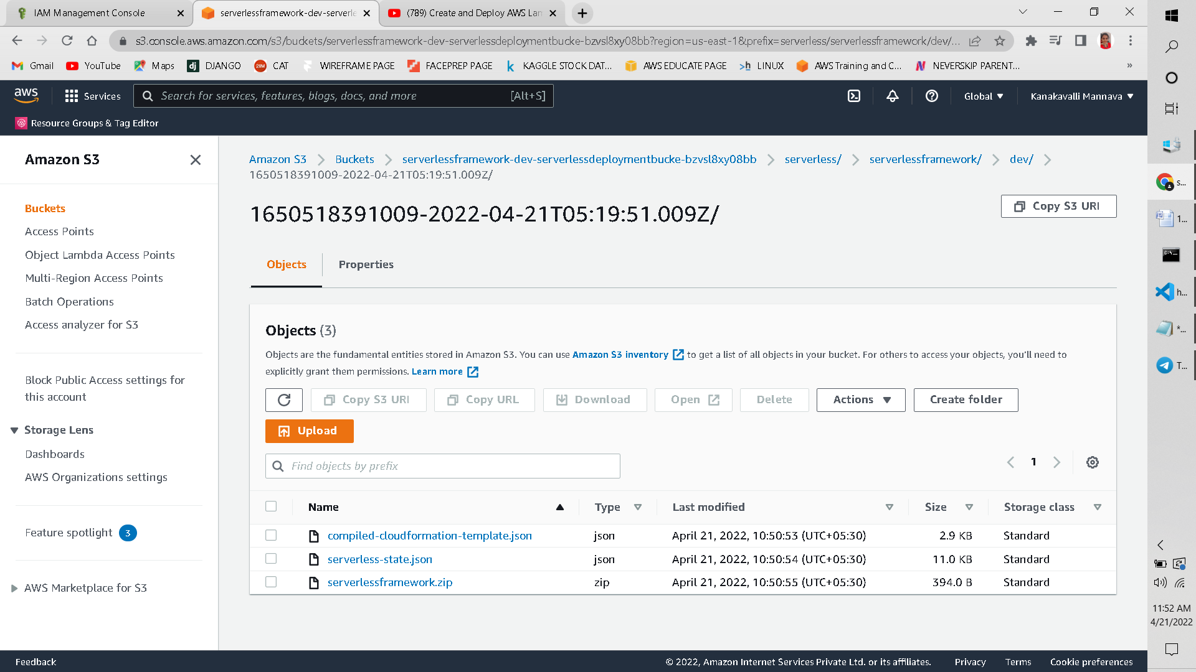

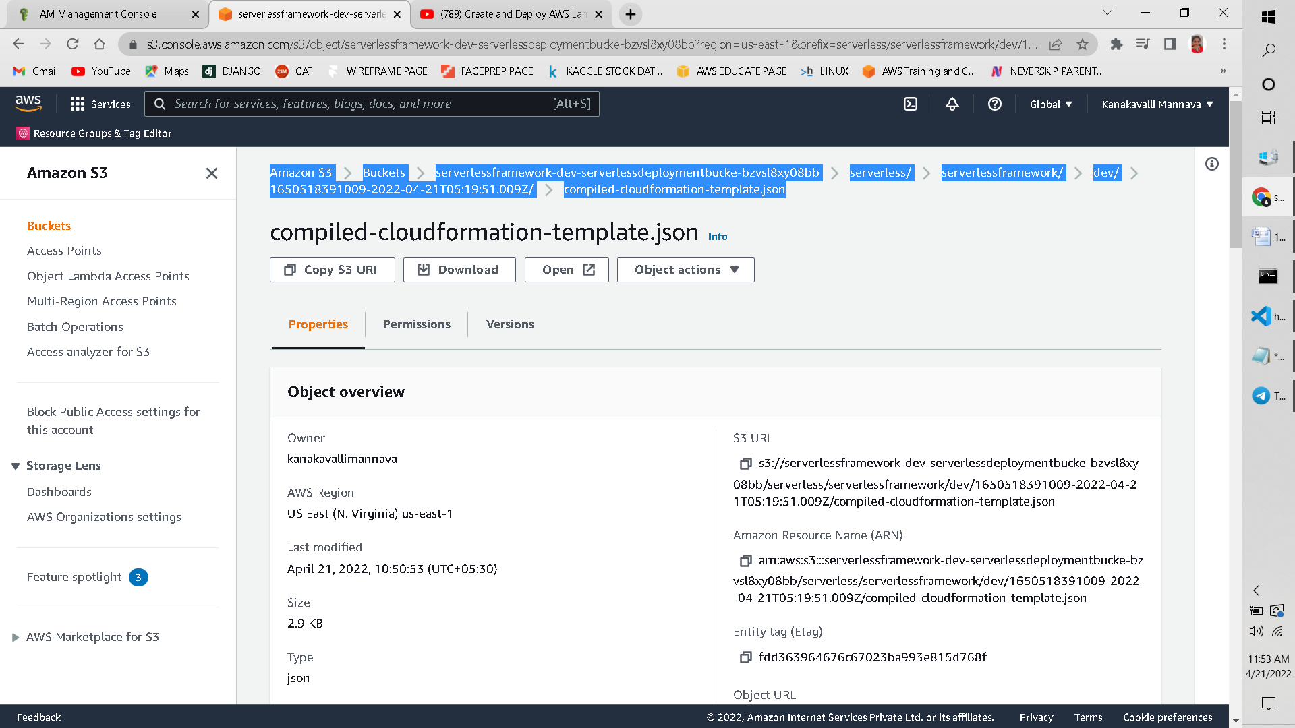

CleanUp:

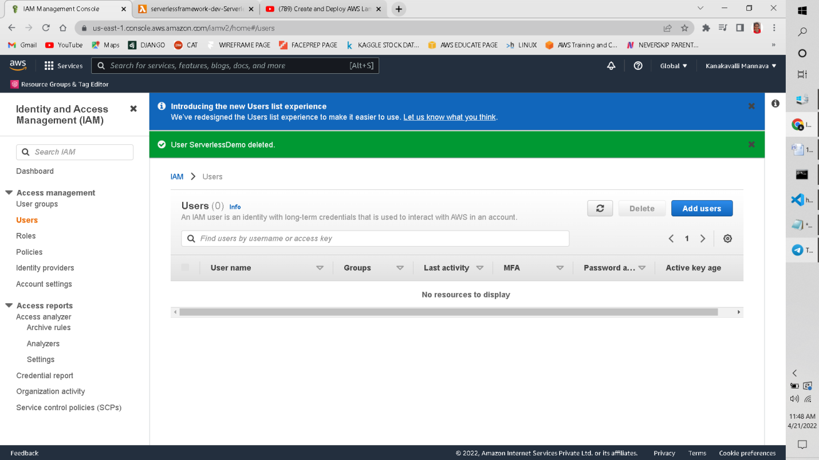

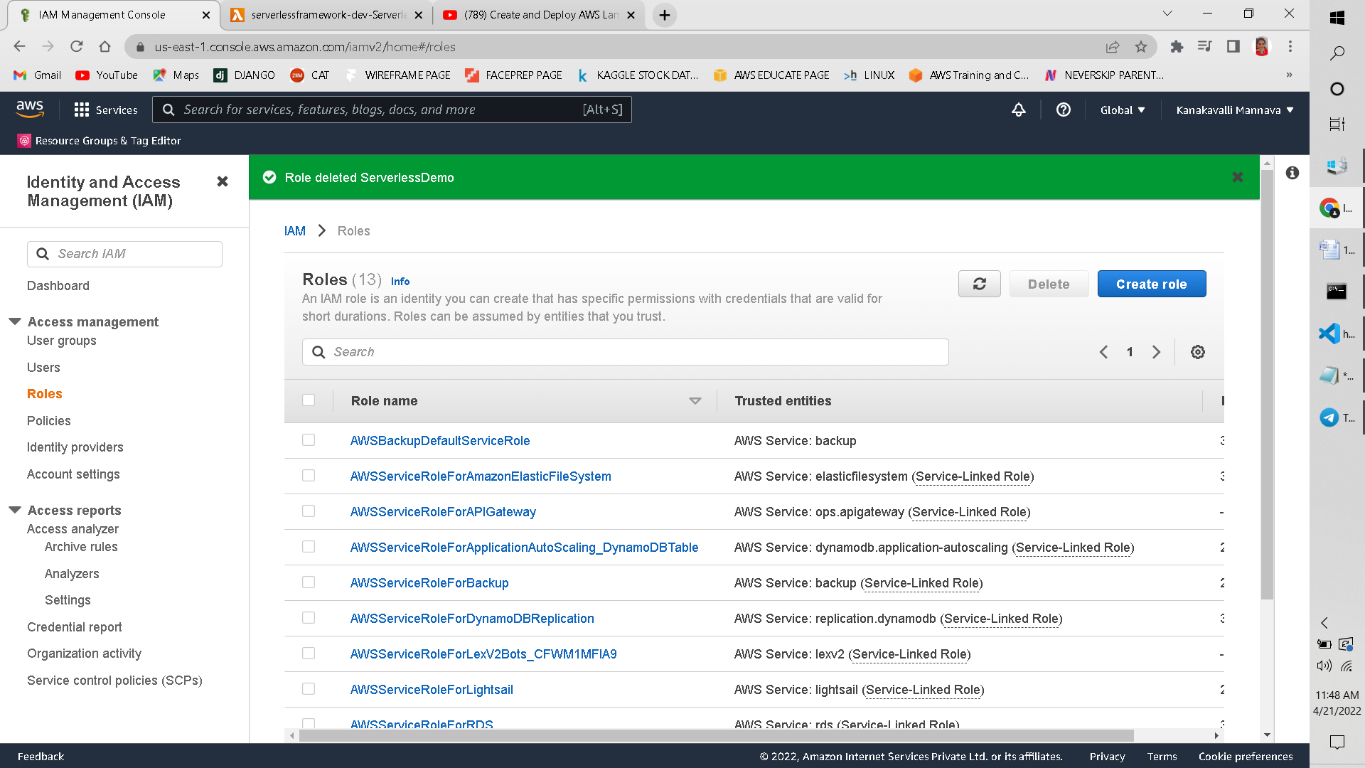

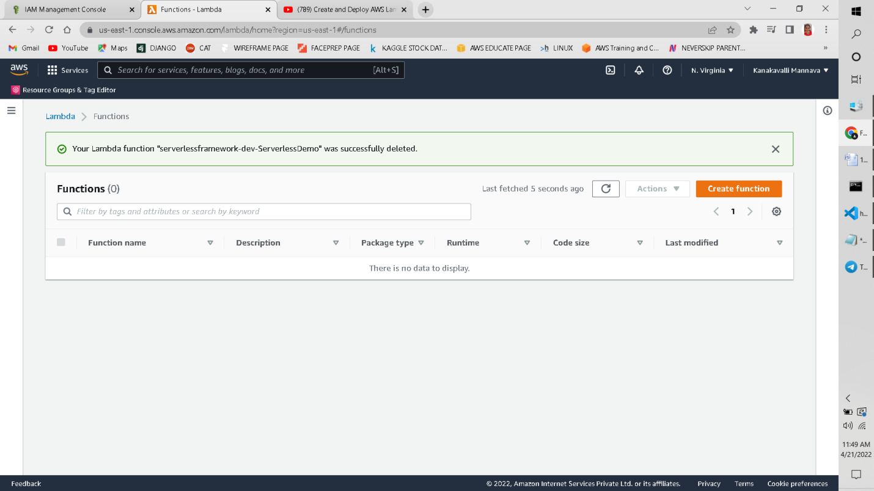

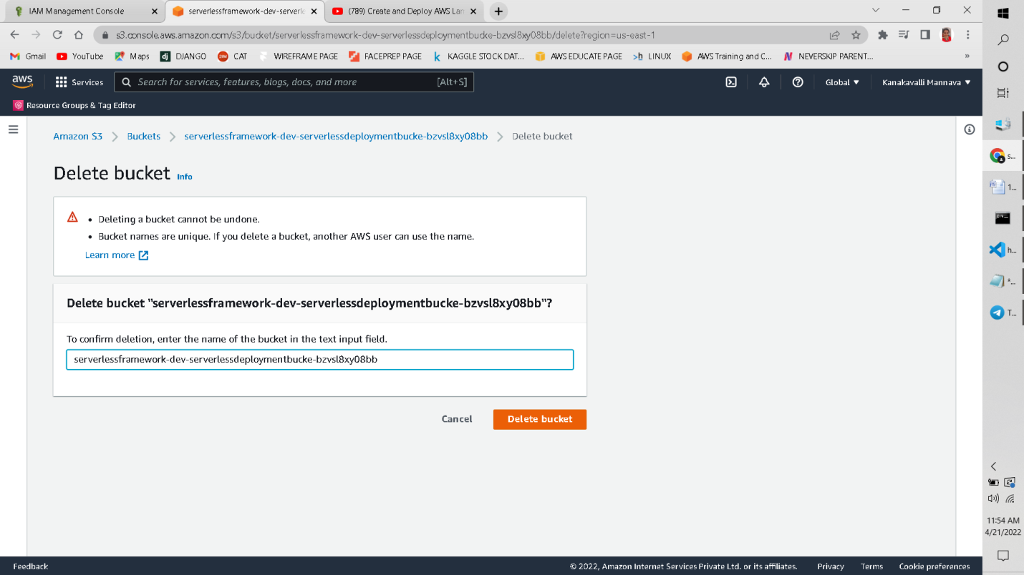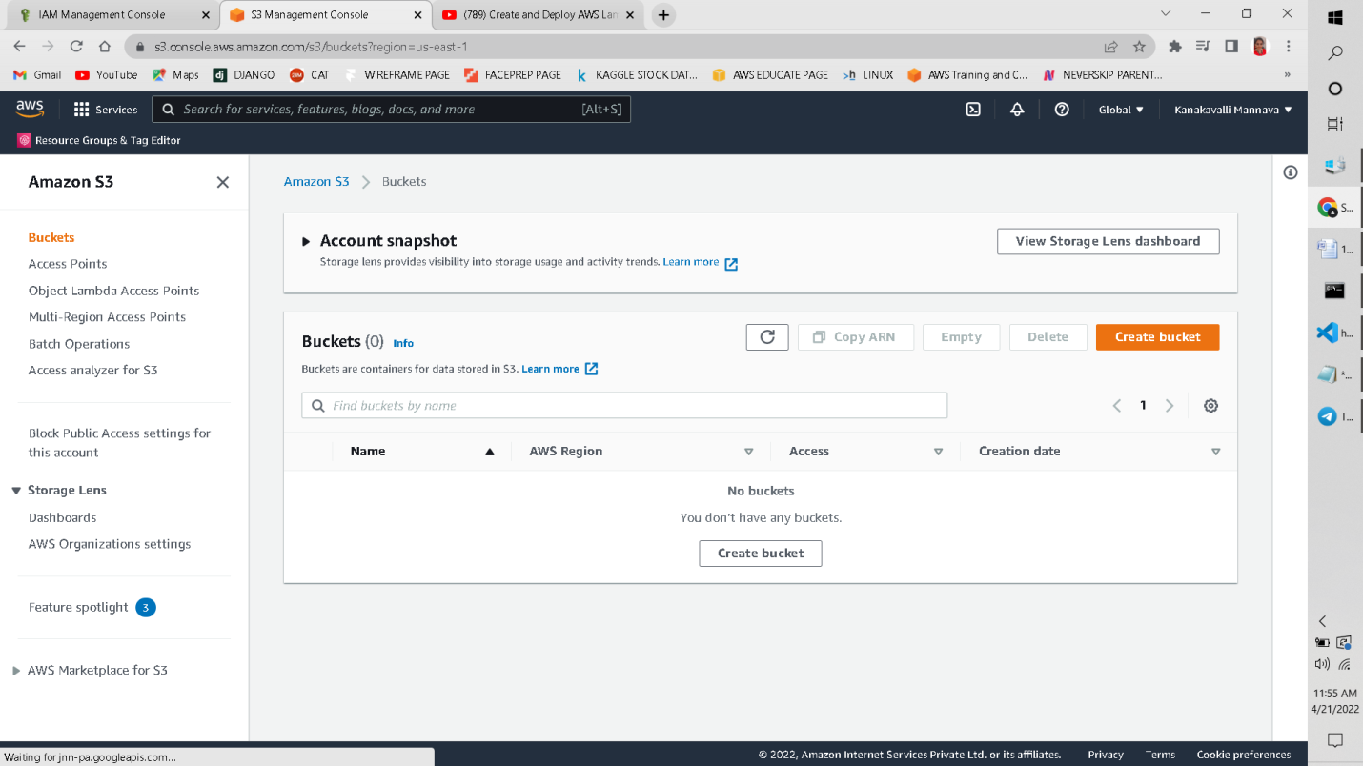

Conclusion:

In this way, we can automatically create serverless service LAMBDA provided by AWS using serverless technology through NodeJS, Visual Studio Code and IAM Users and Roles by writing code to integrate with Lambda Function.

-----------------------------------------------------